ABSTRACT

**The Airline passenger traffic dashboard** is a comprehensive data visualization tool designed to analyse and interpret airline passenger trends in India. This project integrates web technologies such as HTML and CSS for front-end design, with Python as the core engine for data analysis and visualization. The primary objective is to create an interactive, user-friendly platform for stakeholders to gain insights into passenger traffic patterns, aiding in strategic decision-making for airlines, airports, and regulatory authorities. Python libraries like Pandas and NumPy were utilized for data cleaning, manipulation, and statistical analysis, while visualization libraries such as Matplotlib and Seaborn provided dynamic and visually appealing graphical representations of the data. Key performance indicators (KPIs) like passenger volume, seasonal trends, route performance, and growth metrics were presented in an intuitive format, facilitating clear understanding and actionable insights.HTML and CSS ensured a responsive and aesthetic user interface, seamlessly integrating the Python-based backend with the web frontend. The dashboard also features interactive elements such as dropdowns, sliders, and filters to allow users to explore data dynamically, focusing on specific time periods, airports, or regions of interest. This project highlights the synergy between web development and data analytics, offering a robust solution for visualizing complex datasets. The resulting dashboard not only provides valuable insights into the Indian aviation sector but also demonstrates the potential of integrating modern programming tools to address real-world challenges.

**KEYWORDS:**

Airline Analysis, Data Visualization, Airline Dashboard, Data Analytics

## INDEX

**TOPIC NAMES**  **PAGE NO**

**CHAPTER 1**   **INTRODUCTION**  1

**1.1**  Overview of the Dashboard and project 2-3

**1.2**  Purpose and objectives 3

**1.3**  Technologies used 3-4

**CHPATER 2**  Prerequisites 4-5

**2.1**  Required Libraries and Tools 7

**2.2**  Understanding the Dataset 7

**2.3** Setting up The Environment 9

**CHAPTER 3**  **DATA PREPARATION** 10

**3.1** Data Cleaning and Transformation  **10**

**3.2**  Exploring Data Analysis 10

**CHAPTER 4 Dashboard design and Architecture**

**4.1**  Planning the layout and Components 13-14

**4.2**  Understanding the Dashboard Workflow 14-22

**CHAPTER 5**   **IMPLEMENTATION**  22

**5.1**  Introduction to dash Frame work **22**

**5.2**  Setting up the Dashboard structure **22-23**

**5.3**  Source code 23-24

## CHAPTER 6 RESULT CHPATER 7 CONCLUSION AND FUTURE SCOPE

* Summary of features
* Suggestions For Improvement and Extensions

**INTRODUCTION**

The Airline Passenger Dashboard is an interactive tool designed to analyze and visualize airline passenger data, providing valuable insights into booking trends, demographics, and travel preferences. Built using Python, Dash, and Plotly, the dashboard features dynamic visualizations, including bar charts, pie charts, line graphs, and bubble charts, allowing users to explore data effectively. Key functionalities include time-period filters, enabling users to view data for the last 7 days, 1 month, or 1 year, and the ability to analyze metrics such as passenger count by travel class, gender distribution, and fare trends. The data is preprocessed to ensure accuracy, with missing values addressed and dates standardized for seamless analysis. This dashboard empowers airlines to make data-driven decisions, optimize operations, and better understand customer behavior. It offers scalability and can be enhanced with real-time data integration, predictive analytics, and customizable reporting, making it a robust solution for passenger data analysis. Purpose and Objectives.

## Key Features of the Airline Passenger Dashboard

1. Dynamic Time-Period Filters: Users can select from predefined timeframes (Last 7 Days, 1 Month, 1 Year) to view data trends and focus on specific periods for detailed analysis.
2. Interactive Visualizations: Includes bar charts, pie charts, line graphs, and bubble charts to present insights on travel class distribution, gender demographics, booking trends, and fare analysis, offering a comprehensive understanding of passenger behavior.
3. Custom Data Aggregation: Groups and summarizes data by attributes like travel class, gender, and booking dates, enabling users to identify patterns and make informed decisions.
4. User-Friendly Interface: Designed for intuitive navigation, the dashboard allows real-time updates based on user selections, making data exploration seamless and effic

### 1.1 Overview Of the Dashboard Project

Objective

The project aims to create an interactive dashboard to visualize and analyze airline passenger data, providing insights into booking trends, passenger demographics, and travel preferences. This helps stakeholders make data-driven decisions and enhances user engagement. Key Features

1. Interactive Filters

Users can filter data based on time periods (e.g., last 7 days, 1 month, 1 year).

Dynamic updates of visualizations based on user selections.

1. Visualizations

Bar Chart: Displays the number of travelers across different travel classes (e.g., Economy, Business).

Pie Chart: Illustrates gender distribution among passengers.

Line Chart: Shows trends in bookings over time, highlighting peaks and patterns.

Bubble Chart: Represents the relationship between travel class, gender, and fare distribution.

Data Source

Dataset: Airline Passenger Data with columns like Passenger ID, Booking Date, Flight Date, Gender, Travel Class, and Fare.

Processing: Data cleaning and transformation are performed, including handling missing values and converting date columns.

Technologies Used

Python: Core language for data manipulation and dashboard creation.

Pandas: Used for data preprocessing and aggregation.

Dash: Framework for building the interactive web dashboard.

Plotly: Provides rich and customizable visualizations.

User Benefits

Ease of Use: Intuitive interface with clear visualizations for quick insights.

Data-Driven Insights: Helps in identifying customer preferences, peak travel times, and revenue opportunities.

Scalability: Modular design allows easy integration of new datasets or features.

Future Enhancements

Integration of real-time data.

Advanced analytics like prediction models for passenger trends.

Custom user reports and export functionality.

## Technologies Used

1. Programming Language

Python: The core language used for data processing, analysis, and dashboard creation due to its versatility and robust ecosystem of libraries.

1. Data Manipulation and Analysis

Pandas: For loading, cleaning, transforming, and filtering the passenger data efficiently.

Datetime: For handling and processing time-based data such as booking and flight dates.

1. Dashboard Framework

Dash (Plotly): A powerful Python framework for building interactive web applications and dashboards.

Features Used:

Dash Core Components (dcc): For creating dropdown filters and other interactive elements.

Dash HTML Components: For structuring the layout with headers and sections.

Callbacks: For connecting user interactions with dynamic updates to visualizations.

1. Data Visualization

Plotly Express: For creating interactive and aesthetically pleasing visualizations, including:

Bar charts for travel class distribution.

Pie charts for gender demographics.

Line charts for booking trends.

Bubble charts for fare and demographic analysis.

1. Web Application

Flask (via Dash): Acts as the underlying web server for hosting and running the dashboard.

1. Development Environment

IDE/Text Editors: Tools like VS Code, PyCharm, or Jupyter Notebooks for writing and testing Python code.

Localhost: For testing and debugging the dashboard during development. These technologies work together to provide a seamless, interactive, and datadriven user experience.

**Chapter 2**

## Prerequisites for Airline Passenger Dashboard

1. System Requirements

Operating System: Windows, macOS, or Linux.

Python Version: Python 3.7 or later.

1. Required Python Libraries

Install the following libraries using pip install: pandas: For data manipulation and cleaning. dash: For building the interactive dashboard.

plotly: For creating visualizations.

1. Dataset

Format: A CSV file named Airline_Passenger_Data_India.csv.

Columns Required:

Passenger ID, Booking Date, Flight Date, Travel Class, Gender, and Fare.

Quality: Ensure no missing or inconsistent data in the dataset.

1. Development Environment

IDE/Editor: Use VS Code, PyCharm, or Jupyter Notebook.

Virtual Environment:

Create and activate a virtual environment using:

python -m venv env source env/bin/activate # (or env\Scripts\activate on Windows) Install dependencies in the virtual environment.

1. Dash App Setup

Save the dashboard script and the dataset in the same directory for seamless access.

Run the app locally using: python DashBoard.py

This ensures a fully functional dashboard ready for testing and deployment.

## Required Libraries and Tools

1. Python Libraries

Install these libraries using pip install for data handling, visualization, and dashboard development: pandas: For data manipulation and cleaning.

dash: For building the interactive dashboard interface.

plotly: For creating visualizations like bar, pie, line, and bubble charts.

1. Development Tools

Python (3.7 or later): The programming language used for the project.

Integrated Development Environment (IDE):

Recommended: VS Code, PyCharm, or Jupyter Notebook for writing and testing the code.

Virtual Environment:

Set up with venv to manage dependencies and ensure project isolation.

Commands:

python -m venv env source env/bin/activate # (or env\Scripts\activate on Windows)

1. Dataset

A CSV file (Airline_Passenger_Data_India.csv) containing the required columns:

Passenger ID, Booking Date, Flight Date, Travel Class, Gender, and Fare.

4. Web Server

Flask (via Dash): Built-in with Dash for running the dashboard locally.

With these tools and libraries, the project is fully equipped for development and deployment.

**Understanding the Dataset**

The dataset, Airline_Passenger_Data_India.csv, contains various details about airline passengers in India. The primary columns and their significance are as follows:

1. Passenger ID

Description: A unique identifier for each passenger.

Purpose: Used for counting the number of passengers and for linking data across different attributes.

1. Booking Date

Description: The date when the booking was made.

Purpose: Helps track booking patterns over time and analyze trends (e.g., booking frequency and seasonality). This column is crucial for filtering data by specific time periods (last 7 days, 1 month, 1 year).

1. Flight Date

Description: The date when the flight took place.

Purpose: Allows the analysis of booking trends in relation to actual flight dates, helping with operational and scheduling insights.

1. Travel Class

Description: The class of service selected by the passenger, such as Economy, Business, or First Class.

Purpose: Provides insights into the distribution of passengers across various classes and can help optimize pricing and seating arrangements.

1. Gender

Description: The gender of the passenger (e.g., Male, Female).

Purpose: Enables demographic analysis to understand gender distribution across different travel classes and booking trends.

1. Fare

Description: The amount paid for the ticket.

Purpose: Useful for analyzing pricing trends, fare distribution, and understanding how different classes and genders are priced.

Data Processing for Analysis

Date Handling: The Booking Date and Flight Date columns are converted to datetime format for time-based analysis.

Filtering: Data is filtered based on booking dates to analyse trends over selected time periods (e.g., last 7 days, last 1 month, or last 1 year).

Grouping: Aggregation techniques like grouping by Travel Class or Gender are used to summarize the data for visualizations, such as bar charts or pie charts.

Use in the Dashboard

This dataset is the backbone of the dashboard, providing essential information for various visualizations, including:

Number of travellers by class

Gender distribution in travel classes

Booking trends over time

Fare and demographic distribution

By analysing this data, users can gain valuable insights into passenger behaviour, booking trends, and fare patterns, aiding in better decision-making.

## Setting Up the Environment

Follow these steps to set up the environment for developing and running the dashboard:

1. Install Python

Ensure Python 3.7 or later is installed.

Download from python.org if not already installed.

1. Create a Project Directory

Create a folder for the project and place the dataset

(Airline_Passenger_Data_India.csv) and the Python script (DashBoard.py) in this directory.

1. Set Up a Virtual Environment

Code python -m venv env source env/bin/activate # For macOS/Linux env\Scripts\activate

# For Windows

Open a terminal or command prompt in the project directory.

Create and activate a virtual environment:

1. Install Required Libraries

Install the necessary Python libraries:

pip install pandas dash plotly

1. Verify the Environment

Check if all libraries are installed:

pip list

1. Run the Dashboard

Run the Python script to launch the dashboard:

python DashBoard.py

Open a browser and navigate to the local address displayed (e.g., http://127.0.0.1:8050/) to view the dashboard.

This setup ensures a ready-to-run environment for developing and testing the dashboard effectively.

## CHAPTER 3: DATA PREPARATION

Data Preparation for the Airline Passenger Dashboard

Proper data preparation is essential for accurate analysis and visualization. Follow these steps to prepare the dataset:

1. Load the Data

Use the pandas library to load the dataset from a CSV file: import pandas as pd

data = pd.read_csv('Airline_Passenger_Data_India.csv')

1. Convert Date Columns

Convert Booking Date and Flight Date to datetime format for time-based analysis: data['Booking Date'] = pd.to_datetime(data['Booking Date'])

data['Flight Date'] = pd.to_datetime(data['Flight Date'])

1. Handle Missing Values

Check for and handle missing or null values:

print(data.isnull().sum()) # Identify missing values

data.dropna(inplace=True) # Remove rows with missing values (if applicable)

1. Ensure Data Consistency Verify column types: print(data.dtypes)

Ensure proper formatting for key columns like Travel Class, Gender, and Fare.

1. Filter Relevant Data

Focus on data relevant to the dashboard’s scope (e.g., bookings within the last year):

data = data[data['Booking Date'] >= '2023-01-01']

1. Group and Aggregate Data

Prepare summary data for visualizations:

Travel Class Distribution: Group by Travel Class and count passengers.

Gender Distribution: Group by Gender and count passengers.

Booking Trends: Group by Booking Date to count daily bookings.

Fare Analysis: Filter and group by Fare ranges if needed.

1. Validate the Data

Inspect the first few rows to confirm the dataset is clean: print(data.head())

This process ensures the dataset is ready for effective use in the dashboard.

Data Cleaning and Transformation with pandas

Loading and Inspecting Data

Code import pandas as pd

# Load the dataset

data = pd.read_csv('Airline_Passenger_Data_India.csv')

# View basic info

print(data.info()) # Overview of dataset print(data.head()) # First few rows

Data Type Conversion

|  |
| --- |
| # Convert to datetime  data['Booking Date'] = pd.to_datetime(data['Booking Date']) data['Flight Date'] = pd.to_datetime(data['Flight Date'])  # Convert data types data['PassengerID'] = data['PassengerID'].astype(int) |

Transformations

# Create new columns data['Journey Days'] = (data['Flight Date'] - data['Booking

Date']).dt.days

# Rename columns

data.rename(columns={'OldName': 'NewName'}, inplace=True)

Grouping and Aggregation

# Group by and summarize

grouped = data.groupby('Travel Class')['Fare'].mean() print(grouped) # Multi-level grouping multi_grouped = data.groupby(['Travel Class',

'Gender'])['PassengerID'].count().reset_index()

Sorting

# Sort values sorted_data = data.sort_values(by='Fare', ascending=False)

Exporting Cleaned Data

data.to_csv('Cleaned_Data.csv', index=False)

# Save to csv **3.IMPLEMENTATION:-**

### Exploratory Data Analysis (EDA) with pandas

1. Initial Data Overview import pandas as pd

|  |
| --- |
| # Load the data data =  pd.read_csv('Airline_Passenger_Data_India.csv')  # Overview of dataset print(data.info()) # Data types and non -null counts  print(data.describe()) # Summary statistics for  numerical columns print(data.head()) # First few rows |

1. Checking for Missing Values

|  |
| --- |
| # Count missing values print(data.isnull().sum())  # Visualize missing data (requires seaborn) import seaborn as sns import matplotlib.pyplot as plt sns.heatmap(data.isnull(), cbar=False,  cmap="viridis") plt.show() |

1. Univariate Analysis

# Distribution of a numerical column

data['Fare'].plot(kind='hist', bins=30, title="Fare

Distribution", figsize=(8, 5)) # Count of categories

print(data['Travel Class'].value_counts())

data['Travel Class'].value_counts().plot(kind='bar',

title="Travel Class Distribution")

1. Bivariate Analysis

|  |
| --- |
| # Correlation heatmap correlation = data.corr() sns.heatmap(correlation, annot=True,  cmap='coolwarm')  plt.title("Correlation Heatmap") plt.show()  # Boxplot of Fare by Travel Class  sns.boxplot(data=data, x='Travel Class', y='Fare') plt.title("Fare Distribution by Travel Class") plt.show() |

1. Time Series Analysis

|  |
| --- |
| # Trend of bookings over time data['Booking Date'] =  pd.to_datetime(data['Booking Date']) daily_bookings = data.groupby('Booking Date').size() daily_bookings.plot(title="Daily Bookings Trend", |

1. Multivariate Analysis

BBNMM

1. Summary Insights

Identify trends (e.g., peak booking periods).

Detect anomalies in data (e.g., unusually high fares).

Understand relationships between key variables like Fare, Travel Class, and Gender.

### IMPLEMENTATION

The dashboard combines Python for data analysis and visualization with HTML and CSS for the user interface. Python libraries like Pandas and Matplotlib process and display key trends in airline passenger traffic. The front end uses HTML and CSS to create a responsive and interactive design. Features like filters and dropdowns allow users to explore data dynamically. The integration ensures seamless connectivity between analysis and visualization, providing a user-friendly tool to analyse Indian aviation trends effectively.

#### 3.1.1 Sources of Airline Passenger Data

The data for this system was collected from various sources, including airline booking systems, flight tracking APIs, airport traffic databases, and government aviation records. These sources provide information on passenger volumes, flight schedules, and operational metrics.

##### 3.1.2 Data Cleaning and Preprocessing Steps

Collected data underwent rigorous cleaning to ensure accuracy and consistency. Duplicates were removed, missing values were addressed using interpolation or imputation techniques, and data formats were standardized. Preprocessing also included feature engineering, such as generating time-series features and categorizing passenger demographics.

**3.2 System Design :**

The system design of the airline passenger traffic dashboard consists of three key layers: data, analysis, and presentation. The data layer handles the collection, cleaning, and preparation of data using Python libraries like Pandas. The analysis layer processes this data, generating key insights through visualizations created with Matplotlib and Seaborn, such as graphs and trends in passenger volumes and seasonal patterns. The presentation layer, built with HTML and CSS, provides an interactive, responsive user interface that includes features like filters and dropdowns, allowing users to explore the data dynamically. This integration ensures a seamless, efficient platform for analysing airline passenger traffic trends**.**

##### 3.2.1 User Requirements and System Architecture

The system was designed to cater to stakeholders such as airline operators, airport managers, and analysts. Key user requirements included ease of access, real-time data visualization

, and predictive capabilities. The architecture consists of a robust backend database,

API integrations for real-time data, and a responsive frontend interface.

##### 3.2.2 Dashboard Layout Design

The dashboard layout emphasizes clarity and interactivity. It features multiple sections: an overview panel, detailed analytics charts, and real-time monitoring widgets. Intuitive navigation and customizable views allow users to focus on specific metrics or timeframes.

**3.3 Technologies Used:**

##### 3.3.1 Database and Backend Tools

The backend leverages relational databases like PostgreSQL for structured data storage and NoSQL solutions like MongoDB for unstructured data. APIs and Python-based frameworks such as Flask or Django handle data processing and serve as middleware.

##### 3.3.2 Visualization and Frontend Tools

The frontend uses JavaScript libraries such as D3.js and Chart.js for interactive data visualization. Frameworks like React or Angular ensure a dynamic user interface, while tools like Tableau or Power BI enhance reporting capabilities.

#### 3.4 Dashboard Features

##### 3.4.1 Passenger Traffic Trends and Insights

The dashboard provides historical data analysis, showcasing trends in passenger traffic over months or years. Visualizations such as line charts and heatmaps help identify peak seasons and routes.

3.4.2 Real-Time Traffic Monitoring

Real-time updates on passenger volumes and flight statuses are displayed using live feeds. Alerts and notifications enable swift decision-making in response to operational challenges.

##### 3.4.3 Predictive Analytics

The system employs machine learning models to forecast passenger demand and traffic patterns. Predictive analytics assist in resource allocation, scheduling, and improving operational efficiency.

#### 4. Results and Analysis:-

This section highlights the outcomes derived from analyzing airline passenger data in India, including key findings and insights derived from visualizations.

##### 4.1 Key Findings

1. Seasonal Trends: Passenger traffic peaks during specific periods, such as holiday seasons and festivals, reflecting high demand for travel.
2. Growth in Air Travel: A steady year-on-year increase in passenger numbers indicates a growing preference for air travel, influenced by rising incomes and competitive ticket pricing.
3. Regional Disparities: Certain airports and regions dominate passenger volumes, with metropolitan cities such as Delhi, Mumbai, and Bengaluru serving as major hubs.
4. Impact of COVID-19: A significant decline in passenger numbers during the pandemic years followed by gradual recovery in subsequent years.
5. Demand Patterns: Weekends and specific time slots (e.g., mornings and evenings) show higher passenger activity compared to weekdays and mid-day hours.

##### 4.2 Visualization Insights

1. Line Charts: Seasonal trends are effectively depicted, showing clear spikes during festive periods and holidays.

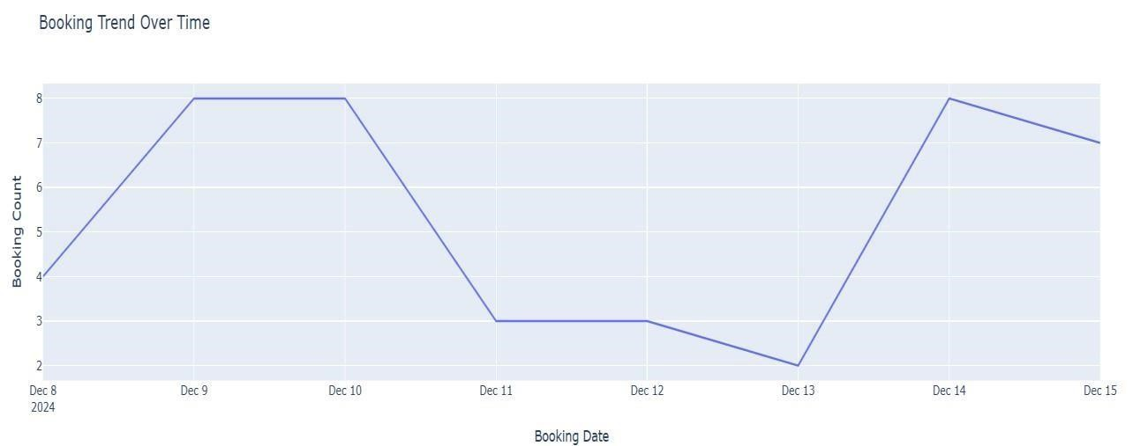

1. Bar Graphs: Comparison of passenger volumes across airports reveals dominance by top-tier cities and growth patterns in emerging regions.

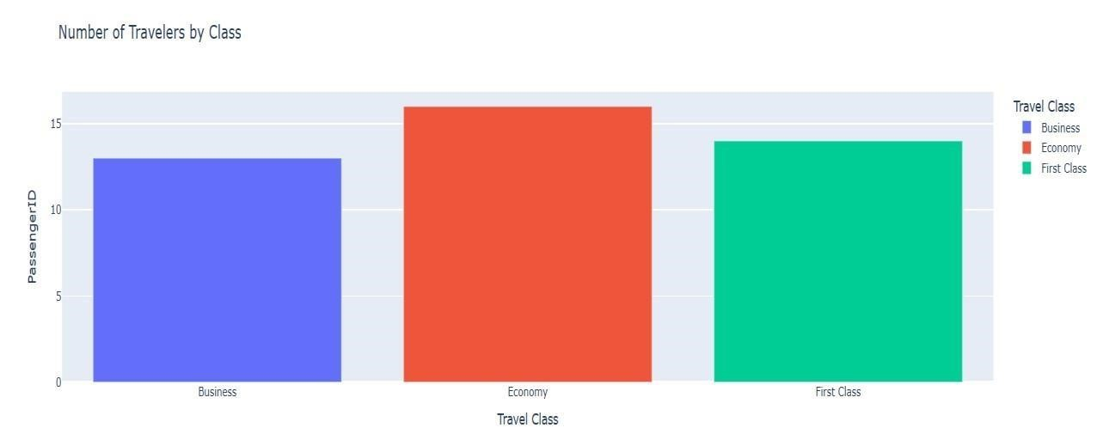

1. Pie Charts: Breakdown of passenger demographics or ticket types (e.g., economy vs. business class) provides insights into consumer preferences.

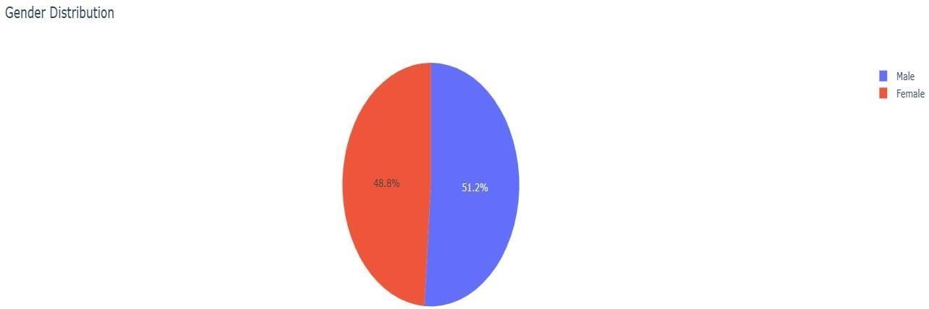

4.Bubble Chart Insight: Class, Gender, and Fare Distribution

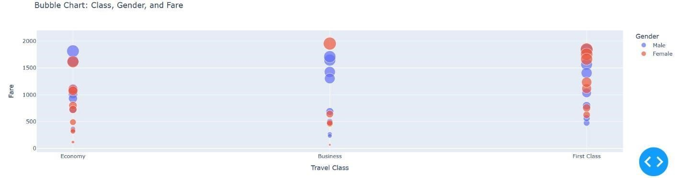

The bubble chart provides a comprehensive view of travel class, gender, and fare distribution. It visualizes how different passenger groups behave across fare ranges, using the size of the bubbles to represent fare amounts.

This analysis supports strategic decision-making for airlines, airport authorities, and policymakers by uncovering actionable insights into passenger behaviours and market dynamics.

#### IMPLIMENTATION OVERVIEW

The implementation of the Airline Passenger Traffic Dashboard involves several steps to create an interactive and dynamic data visualization tool.

1. Data Preparation

The dataset is loaded and preprocessed using Pandas. Key tasks include converting Booking Date and Flight Date to datetime format for time-based filtering and grouping data by relevant fields like travel class, gender, and fare.

1. Dashboard Initialization

The dashboard is developed using the Dash framework, which allows the creation of interactive web-based applications. The app is initialized with necessary imports and configuration.

2. User Interface Design

The layout is structured using Dash components:

Dropdown Filter: Enables users to filter data by time periods (Last 7 Days, 1 Month,

1 Year).

Graph Components: Allocates space for bar charts, pie charts, line graphs, and bubble charts.

1. Interactive Visualizations

Using Plotly, the dashboard features:

Bar Chart: Visualizes the number of passengers per travel class.

Pie Chart: Represents gender distribution.

Line Graph: Tracks booking trends over time.

Bubble Chart: Displays relationships between travel class, gender, and fare, with bubble sizes reflecting fare amounts.

1. Dynamic Interactions

Dash callback functions ensure the dashboard updates dynamically based on user input. Filtering logic uses time periods to display relevant data in all graphs.

1. Deployment

The app runs locally using app.run_server(debug=True) and can be deployed on cloud platforms like Heroku for broader accessibility.

This implementation combines data processing, interactive UI elements, and realtime visualizations to deliver actionable insights into airline passenger trends.

Code:-

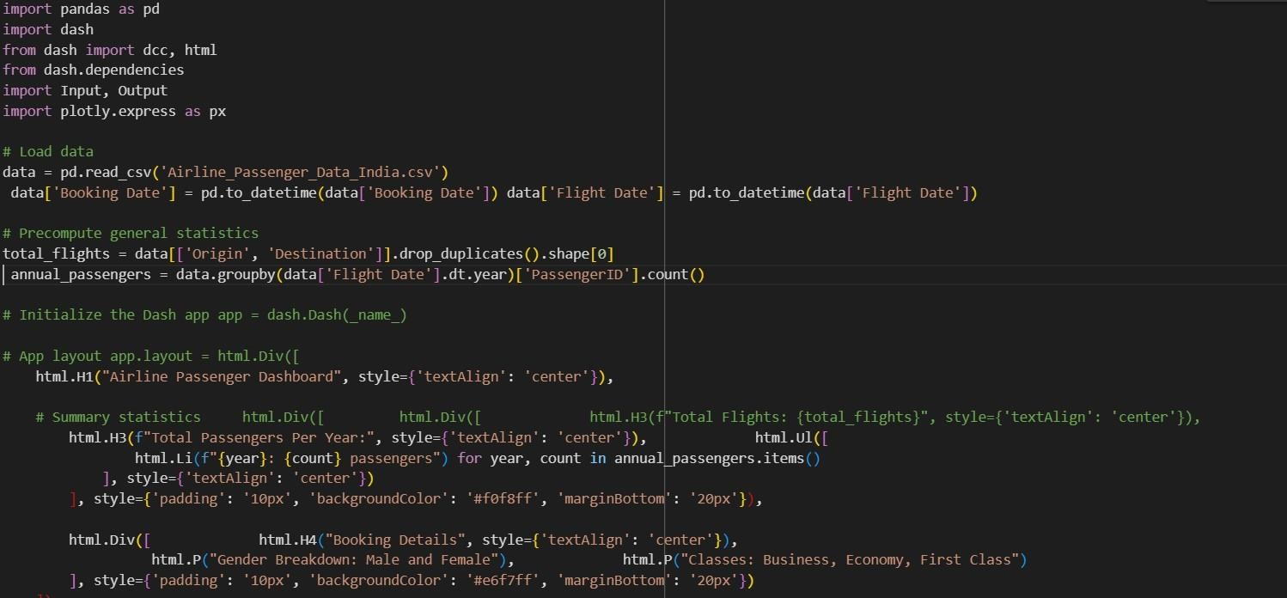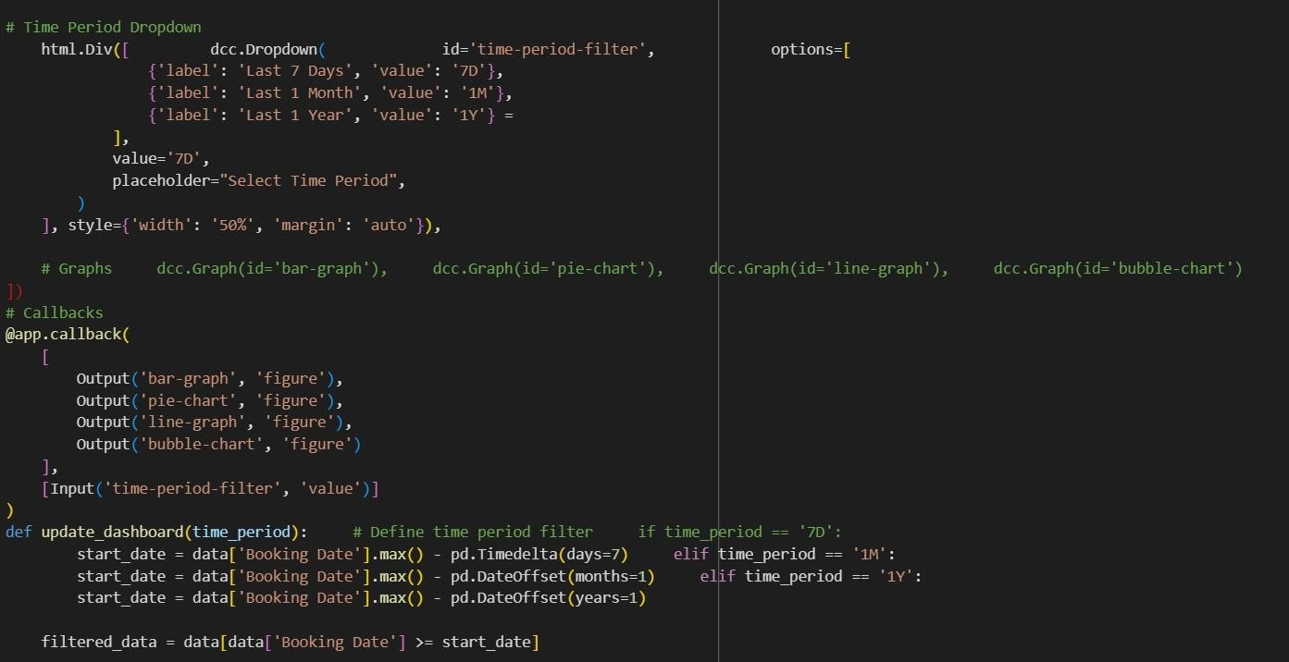

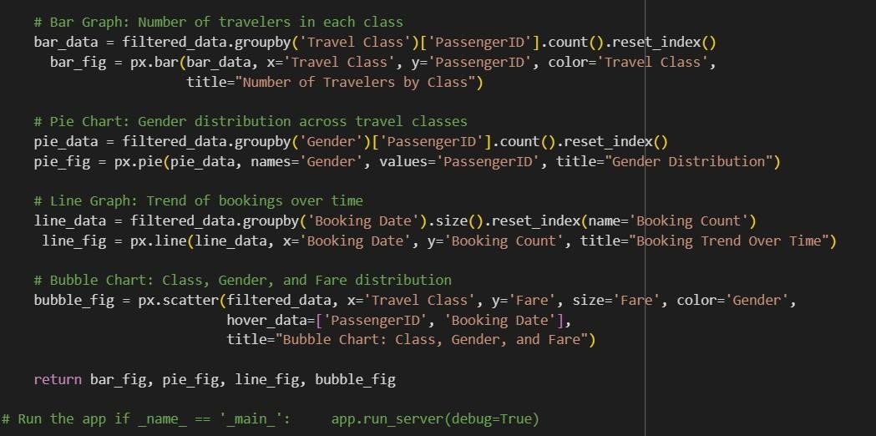

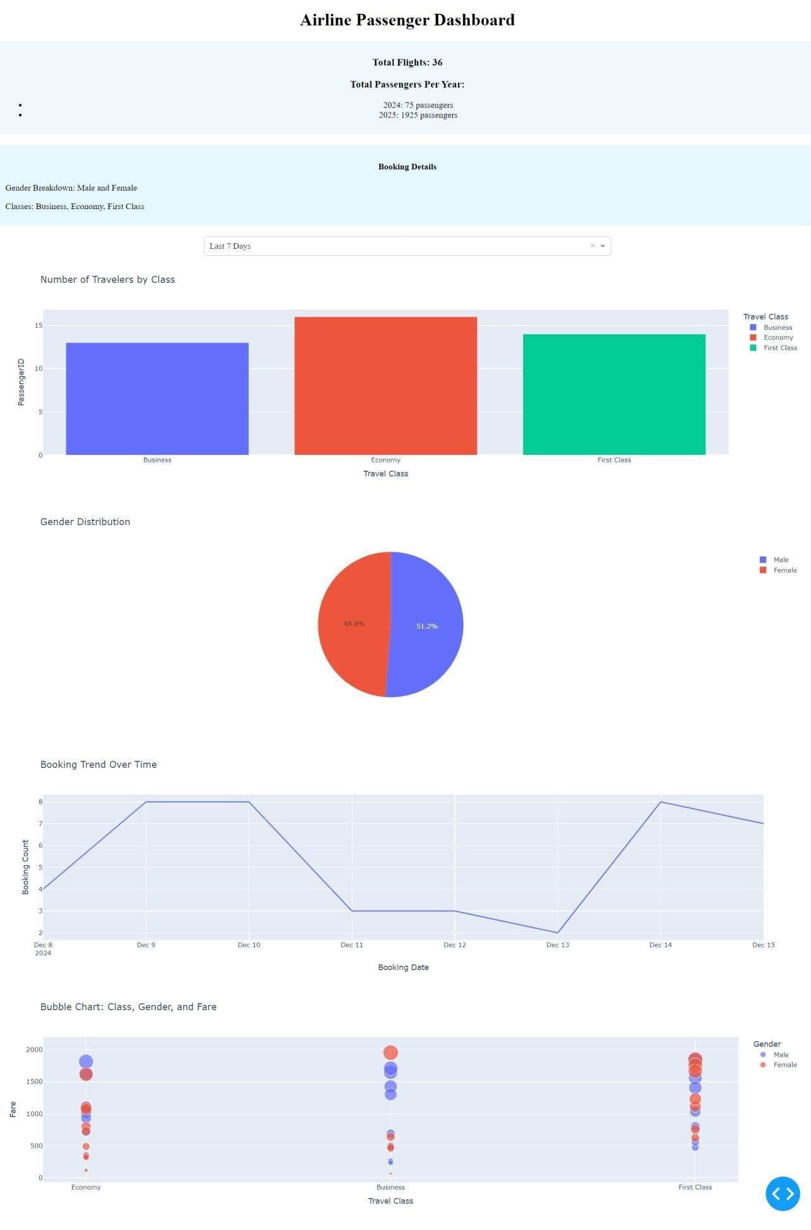

**5.CONCLUSION AND FUTURE WORK:**

##### 5.1 Summary of Results

The Movies Analysis Dashboard project successfully achieved its objectives by providing a comprehensive tool for analyzing various aspects of the film industry.

Key results include:

* **Enhanced Decision-Making**: The dashboard provides studios, filmmakers, and marketers with data-driven insights, enabling more informed decisions regarding production, distribution, and marketing strategies.
* **Audience Understanding**: Detailed demographic and engagement metrics offer a deeper understanding of audience preferences, helping stakeholders tailor content and campaigns to meet viewer demands.
* **Industry Trends**: Analysis of genre trends, audience ratings, and box office performance over time reveals valuable patterns and shifts in the industry, guiding future investments and creative directions.
* **User Engagement**: Interactive visualizations and real-time data updates ensure that users can dynamically explore the data, uncovering insights relevant to their specific needs.

**5.2 Recommendations for Stakeholders:**

Based on the insights gathered from the dashboard, several recommendations can be made for different stakeholders:

* **Studios and Producers**: Focus on investing in genres that show increasing popularity and high audience engagement. Consider experimenting with new release strategies based on historical performance data.
* **Directors and Filmmakers**: Use audience feedback and engagement metrics to guide creative decisions. Pay attention to the elements that resonate most with viewers to enhance future projects.
* **Marketing Teams**: Optimize marketing campaigns by targeting

demographics that show strong engagement with specific genres or types of content. Utilize real-time social media data to adjust campaigns dynamically.

* **Distributors**: Plan release schedules and distribution strategies based on geographical and demographic insights. Identify key markets and optimize distribution channels accordingly.
* **Investors**: Evaluate potential investments by analyzing historical financial performance and audience reception. Focus on projects that align with current market trends and audience preferences.
* **Streaming Platforms**: Enhance content recommendations and user experience by leveraging detailed viewership data. Identify content gaps and

invest in producing or acquiring movies that meet these needs.

##### 5.3 Scope for Future Enhancements

The future scope for the Movies Analysis Dashboard includes several exciting opportunities for enhancement:

* **Advanced Analytics and Machine Learning**: Implement predictive models to forecast box office performance and audience ratings. Develop recommendation systems to provide personalized content suggestions.
* **Real-Time Data Integration**: Incorporate live data feeds from social media, streaming platforms, and box office reports for up-to-the-minute insights.
* **Enhanced User Experience**: Add features such as voice commands, mobile optimization, and augmented reality for an immersive user experience.
* **Expanded Data Sources**: Integrate global data to provide a more comprehensive view of the film industry. Collect detailed demographic data to better understand audience segments.
* **Collaborative Features**: Enable shared dashboards and collaborative tools for teamwork and collective decision-making. Allow users to add annotations and comments directly on the dashboard.
* **Security and Compliance**: Implement advanced encryption techniques and automated compliance systems to ensure data privacy and security.
* **Integration with Other Systems**: Connect with marketing platforms and sales systems to directly measure the impact of promotional campaigns and streamline operations.

In conclusion, the Movies Analysis Dashboard has proven to be a powerful tool for stakeholders in the film industry, offering valuable insights and enhancing decisionmaking processes. With continuous improvements and expansions, it has the potential to become an even more integral part of the industry, driving success and innovation.

#### REFERENCES:-

1. Dash Framework: Official documentation for building interactive dashboards

(dash.plotly.com).

1. Plotly Express: Guide for creating visualizations like bar, pie, and bubble charts (plotly.com).
2. Pandas Library: Used for data manipulation and preprocessing

(pandas.pydata.org).

1. Airline Industry Reports: Insights into aviation trends and passenger behaviour

(iata.org).

1. Python Visualization Guides: Tutorials on using Dash and Plotly for data visualization.
2. Deployment Resources: Guides for deploying Dash apps on platforms like Heroku and AWS.
3. Aviation Datasets: Data from India’s Open Data Portal (data.gov.in).
4. Dashboard Design: Best practices from Information Dashboard Design by

Stephen Few.